GTB  
  
**QA**  
[DEV 20.20] OT-869 | AA | BENL | HP | HPR Range Personalisation | SUV – 26 May 2020

**Jira ticket:**  
<https://jira.uhub.biz/browse/GTBEMEAOPT-869>

**Site**  
<https://www.nl.ford.be/>

**Test location**  
Homepage Rotation

**Tags**

CONTROL: tt:nwp:opt-869:ab:hp:hpr-suv:control

CHALLENGER B: tt:nwp:opt-869:ab:hp:hpr-suv:var-b

CHALLENGER C: tt:nwp:opt-869:ab:hp:hpr-suv:var-c

**Hypothesis**

The results for the most recent round of personalisation highlights that there is an opportunity to try a new approach on the homepage. Indeed, the previous round of testing, which retargeted with a single-vehicle personalised HPR for audiences such as NPP Visits, BP-A, BP-C, TDR-A, TDR-C, KMI-A, KMI-C and BRD, produced the following results.

For User Case #1, we see higher HPR CTR for people who see default content (control has on avg +104% CTR). Across 3x markets, people who are taken back to NPP are more likely to become BP-C and have +26.2% higher BP-C. This audience is still in the “discover” mode: they don’t want to be stuck into a one-vehicle journey. The fact people who go back to NPP have higher BP-C CR% shows HP might not be the hottest page for BP-C. We should keep targeting this audience on HP, but we should move away from one-vehicle strategies and test showing vehicle range instead (eg SUV).

For the other User Cases, we see higher HPR CTR for people who see default content (control has on avg +166% CTR). Across 3x markets, people who are taken back to NPP are more likely to become BP-C and have +26.4% higher BP-C. BP-A could be BP-C, which is indicated by the fact that people are +56% more likely to click on default than the BP slide. The fact people who go back to NPP have higher BP-C CR% shows NPP could be better page. We should target BP Abandons on the NPP, where we could exploit the billboard but also other components and their order on the page; we can keep testing this audience on HP as well but using a ‘range’ strategy.

**Test Description**  
  
**ACTIONS:** These are the actions you can take in order to ‘trigger’ the homepage change. You only need to do one of the actions in order to ‘trigger’ the change on the homepage.

Visiting the Nameplate Page of one of the “SUV” vehicles. The easiest way to do this is from the home page mouseover “Modellen” and click on the “SUV & Crossover” sub-option and then click on either the “ECOSPORT” or the “EDGE”. You are now on the Nameplate Page.

Abandon a Test Drive Request for one of the “SUV” vehicles. The easiest way to do these is to click on the “Testrit” link at the top of the page on the right. Once on this page, select one of the following vehicles “New Ecosport”, “Edge”. Now navigate away from this page. You have now abandoned a test drive request.

Requesting a Brochure for one of the “SUV” vehicles. To this click on the link at the top of the screen, on the mini header that says “Quicklinks”. Then in the drop-down select “Brochures & prijslijsten”. Once on this page, select one of the following vehicles “New Ford Ecosport”, “Ford Edge”. You have now requested a brochure.

Keep Me Informed Abandoned for one of the “SUV” vehicles. To do this, scroll to the bottom of the home page, although I’m certain it’s available sitewide. Click on the “Hou me op de hoogte” button, it is on the bottom right of the page. Once on this page, select one of the following vehicles “New EcoSport”, “Edge”. Now navigate to another page. You have now abandoned the Keep Me Informed action.

Keep Me Informed Completed for one of the “SUV” vehicles. To do this, scroll to the bottom of the home page, although I’m certain it’s available sitewide. Click on the “Hou me op de hoogte” button, it is on the bottom right of the page. Once on this page, select one of the following vehicles “New EcoSport”, “Edge”. Complete the information on the right. Once complete click the “Bevestigen” button at the bottom. You have now completed the Keep Me Informed action.

**RULES:** When an action has been taken and the image is updated. The image would be seen a maximum of 3 times. After which it will no longer display, unless one of the actions are taken again. Taking an action resets the counter on the number of times you’ve seen the billboard. In other words, if you do the action, go to the home page, view it twice and then do another action, you’ll see it 3 more times. Unless you do another action again.

**CHALLENGER B:** View the CHALLENGER B link. Do one of the mentioned **ACTIONS**. Return to the homepage. The first image in the billboard should be the below:

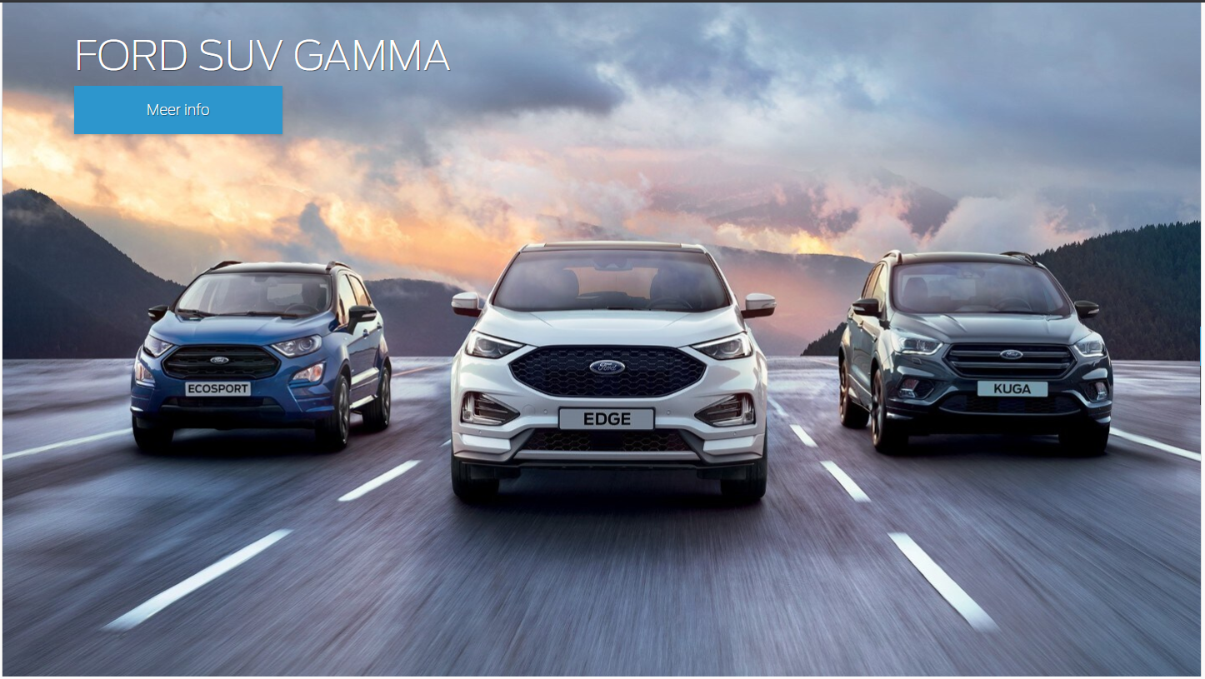

When you click on the billboard, it should take you to: <https://www.nl.ford.be/alle-modellen/ford-suv>

**CHALLENGER C:** View the CHALLENGER C link. Do one of the mentioned ACTIONS. Return to the homepage. The first image in the billboard should be the below:  


When you click on the billboard, it should take you to:  
<https://www.nl.ford.be/alle-modellen> filtering on the SUV & Crossover option.

**Browser:**   
All  
  
**Device:**   
All  
  
**Audience rules:**   
NPP Visits, BP-A, BP-C, TDR-A, KMI-A, KMI-C and BRD who come back to HP

**QA Links:**

**CONTROL / VARIANT 1:**

[**https://www.nl.ford.be?at_preview_token=Fx793ppLWqfy1mUfiGIpLQ%3D%3D&at_preview_index=1_1&at_preview_listed_activities_only=true**](https://www.nl.ford.be?at_preview_token=Fx793ppLWqfy1mUfiGIpLQ%3D%3D&at_preview_index=1_1&at_preview_listed_activities_only=true)

**CHALLENGER B / VARIANT 2:**

[**https://www.nl.ford.be?at_preview_token=Fx793ppLWqfy1mUfiGIpLQ%3D%3D&at_preview_index=1_2&at_preview_listed_activities_only=true**](https://www.nl.ford.be?at_preview_token=Fx793ppLWqfy1mUfiGIpLQ%3D%3D&at_preview_index=1_2&at_preview_listed_activities_only=true)

**CHALLENGER C / VARIANT 3:**

[**https://www.nl.ford.be?at_preview_token=Fx793ppLWqfy1mUfiGIpLQ%3D%3D&at_preview_index=1_3&at_preview_listed_activities_only=true**](https://www.nl.ford.be?at_preview_token=Fx793ppLWqfy1mUfiGIpLQ%3D%3D&at_preview_index=1_3&at_preview_listed_activities_only=true)